Recidivism on Juvenile: Sociology of Juvenile Delinquency Issues
Name:
Institution:
Date:

Abstract
One of the major problems affecting American society today is the significant rate of juvenile delinquency, attributable to urbanization and industrialization of the contemporary society. The increased rate at which adolescent offenders are being rearrested is attributable to engagement in delinquent behaviors. Juvenile delinquency has been associated with drug abuse, domestic violence, poor parenting, poor social status, peer pressure, violent neighborhood, and poorly managed learning institutions (Hirschi, 2017). Repeat criminal offenses among juvenile offenders possess a major challenge to the criminal justice system because of the associated costs, lack of facilities with enough capacity, development with links with criminals, violence, and drug abuse among others. Despite that the rate of recidivism has declined over the years attributable to the effective strategies and intervention measures, there is a need to address the problem, to ensure that the criminal justice system operates this sector seamlessly. Besides, effective intervention programs will ensure that adolescents can conduct productive lives and become successful. This paper aims to address this social problem, recidivism on juvenile and develop intervention strategies that should be put in place to ensure that the rate of minors reengaging in criminal behaviors is minimized.
Introduction
In contemporary society, the challenge of juvenile delinquency has led to the development of different social problems. Increased engagement in criminal behaviors has led to increased insecurity, reduced productivity among minors, engagement in violence, and reduced academic performance. Despite the efforts of the public and private sectors as well as civil society, the rate of juvenile delinquency remains significant. Numerous factors have been associated with increasing the rate of adolescents engaging in criminal behaviors. These factors include poor parenting, low social status, peer pressure, drug abuse, domestic violence, lack of education, and violent neighborhoods (Hirschi, 2017). Although no national statistics are showing the number of minors who are rearrested for engaging in crime, the varies from one state to another and remains significant. According to OJJDP (2019), the number of arrests of minors made in 2018 was approximately 728,280. This is a very large number of adolescents arrested in a single year. However, this value is 60% lea compared to the number of arrests that were made almost a decade ago, 1,906,600 arrests in 2009. These significant statistics show that juvenile delinquency is a major threat to the effective functioning of the criminal justice system.
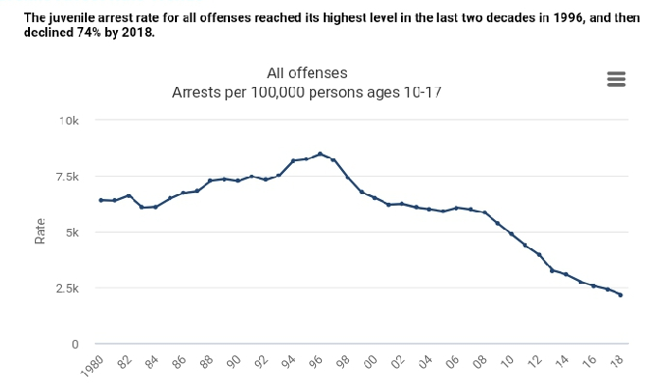
Fig 1: Juvenile arrest trends from 1980-2018.
The issue of juvenile recidivism has been debated on from different schools of thought. There are varying perspectives on the causes of reengagement in crime among minors. These perspectives have initiated a heated debated on the approaches that should be implemented by the criminal justice system, other public institutions, the private sector, and members of civil society. These varying perspectives have also led to the development of effective intervention programs, which should be put in place to ensure the development of delinquent behaviors among minors is minimized (National Academy of Sciences, 2001). To address the growing challenge of juvenile delinquency, the criminal justice system in association with other organizations has played a key role in the process of policy implementation. Developing exemplary policies is imperative because it will ensure that offenses committed by minors are addressed discreetly.
Literature review
Delinquency is a major social problem that not only affects the delinquent individual but also affects family members, the community, and society at large. According to the National Academy of Sciences (2001), juvenile delinquents are a vulnerable population that can be easily manipulated, prompting them to engage in activities like crime and violence, which in turn, lead to poor academic performances, drug abuse, incarceration, or even death. Different approaches have been used to help address the high rate of juvenile delinquency. This includes incarceration, engagement in social work and community development, development of and engagement in extra-curricular activities, physical therapies, rehabilitation, and development of effective education programs.
Effects of juvenile delinquency
The majority of scholars propose that the best approach to address juvenile delinquency is through incarceration. This approach would focus on taking delinquent minors to prisons where they would serve their sentences. However, this approach has its implications. Minors are in a position to develop relationships with serious criminals, who can influence their behaviors. Developing relationships with criminals increases the probability of a minor committing a crime again. These relationships increase the rate of future recidivism (Point Park University, 2019).
Another effect of juvenile delinquency is family instability. According to Weisburd et al (2009), when a member of a family is delinquent, it means that they are subjected to increased financial constraints and ethical issues. When an adolescent engages in criminal behaviors, which lead to vandalism and destruction of property, family members are given the responsibility of covering for the bills and addressing the unethical conduct of the minor. These challenges can lead to family instability and violence.
There is also the effect of increased government expenditure. Juvenile delinquency costs the government millions of dollars yearly, including loss of poverty values, medical bills, destroyed property, and loss of valuable time that can be used in development. The incarceration of minors has been considered to have the highest cost per capita. This shows that the government has been spending extra funds to address the issue of juvenile delinquency (the Legislative Analysis’s Office, 2012). The state of California, for example, has the highest cost per capita, spending $32,000 per year. Comparing this amount to $4200 allocated to K-12 education shows that there is a need to have policies to have less costly intervention programs.
Intervention programs
The process of changing delinquent youths is complex because the behaviors of adolescents are embedded in their personality, i.e., the adolescent stage of development is associated with the determination of one's identity. Therefore, it is a complex process, which needs to be approached with caution. During this stage of development, when young people learn something they get stuck with it. It is imperative to develop intervention programs that can be used to address delinquency and minimize the rate of juvenile recidivism. Implementation of intervention measures is essential because it is less costly, and ensures that minors are kept away from crimes. Besides, it is crucial to have a juvenile system that focuses on rehabilitating minors to help them successfully reintegrate into mainstream society. Members of civil society should also focus on developing relationships with the public and private sector, which in turn, ensures that minors are closely monitored and their personalities shaped inconsistent with the norms of society.
The most appropriate intervention program to address juvenile delinquency is by use of counseling intervention programs. According to Lipsey (2009), counseling intervention programs are effective because a counselor is in a position to understand the needs of minors and address them correctly. These approaches also foster increased engagement in activities, thus the development of a positive personality. The best counseling intervention frameworks are group-based programs that are aimed at mentoring adolescents. Mentoring plays a major role in the reduction of delinquency and aggression behaviors among young people. Through mentoring, it is easy to establish trusted relationships, which encourage young people to open up and ask for help. Through mentoring, counselors can give children the most appropriate advice to adapt to the new environment in society after a period of incarceration. When children open up, mentors can understand their challenges and give advice that can help them succeed.
To measure the effectiveness of this intervention program, I will compare the rate of recidivism between minors who engage in group-based counseling intervention programs and those who do not. Through this criterion, I will be able to determine the success rate of the approach as well as its effectiveness. This is a reliable approach because it can be used to help juvenile delinquents become morally upright children, who are productive and well-behaved.
In conclusion, juvenile delinquency is a challenge that needs to be addressed effectively to guarantee the wellbeing of tomorrow’s generations. To address this challenge, it is important to have intervention programs that can improve the behaviors of young people to conform to the norms of society. The most appropriate intervention program to address this problem is the use of counseling intervention programs, particularly mentoring. Through this approach, juvenile delinquency can be minimized, which in turn, would minimize the rate of recidivism.

References
Hirschi, T. (2017). Causes of delinquency. Routledge.
Legislative Analysis Office. “Juvenile Crime-Costs and Policy Implications.” (2012). https://www.lao.ca.gov/1995/050195-juv>
Lipsey, M. (2009). The primary factors that characterized effective interventions with juvenile offenders: A meta-analytic overview. Victims & Offenders: An International Journal of Evidence-based Research, Policy, and practice, 4(2) 124-147.
National Academy of Sciences. (2001). Juvenile Crime, Juvenile Justice. National Academy Press, Washington DC.
OJJDP Statistical Briefing Book. Online Available: https://www.ojjdp.gov/ojstabb/crime/qa05101.asp? qaDate=2018. Released on October 31, 2019.
Point Park University. (2019). Juvenile Recidivism: A Second Chance. Accessed from https://www.juvenile-recidivism-a-second-chance-point-park-university-online.html
Weisburd, David, Gerben J.N Bruisma and Wim Bernasco. “Units of analysis in geographic criminology: Historical development, critical issues, and open questions.” Putting crime in its place. Springer, New York, NY, 2009. 3-31.

